IMAGE TO AUDIO CONVERSION FOR VISUALLY IMPAIRED PEOPLE USING CNN

## A PROJECT REPORT

***Submitted by***

Kesavan M (19EUIT077) Manikandan M (19EUIT082) Monish Kumar R (19EUIT098)

***In partial fulfillment of the requirements for the award of the degree of***

# BACHELOR OF TECHNOLOGY

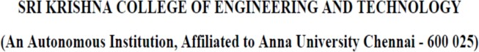**in INFORMATION TECHNOLOGY**

**APRIL 2023**



# BONAFIDE CERTIFICATE

Certified that this project report **“Image to Audio conversion for Visually impaired people using CNN”** is the bonafide work of “Kesaven M (19EUIT077), Manikandan M (19EUIT082), Monish Kumar R (19EUIT098)” who carried out the project work under my supervision.

## SIGNATURE SIGNATURE

[Dr. N SUSILA] [ Mr. Kalaiarasan T R ]

## HEAD OF THE DEPARTMENT SUPERVISOR

Information Technology, Assistant Professor/IT, Sri Krishna College of Engg & Tech, Sri Krishna College of Engg & Tech, Coimbatore-641008. Coimbatore-641008.

This project report submitted for the Autonomous project viva-voice examination held on .

**INTERNAL EXAMINER EXTERNAL EXAMINER**

# ABSTRACT

This project proposes a novel approach to assist visually impaired individuals by converting images into audio. The proposed system utilizes deep learning techniques to extract meaningful features from images and generate corresponding audio descriptions in real-time. The system is designed to be user-friendly, with a simple interface that allows blind individuals to easily capture and process images using a mobile device. To evaluate the effectiveness of the proposed system, a user study was conducted, which showed promising results in terms of accuracy and usability. This project presents a promising solution to improve the quality of life for the visually impaired by providing them with an alternative way to perceive and interact with their surroundings.The proposed image to audio conversion system is aimed at addressing the limitations of existing assistive technologies that rely on textual descriptions or braille. By providing audio descriptions of images, blind individuals can more easily understand visual information that is critical for daily life, such as identifying objects, reading signs, or navigating unfamiliar environments.The system leverages recent advancements in deep learning, which have shown significant improvements in image recognition and natural language processing. As such, the proposed system has the potential to provide more accurate and detailed audio descriptions than current approaches. With further development and refinement, this technology could be integrated into a range of devices, from smartphones to smart glasses, and have a significant impact on the lives of visually impaired individuals.

# CHAPTER NO.

**TABLE OF CONTENTS TITLE**

# PAGE NO.

**ABSTRACT i**

# LIST OF FIGURES v

LIST OF ABBREVIATIONS vii

1. INTRODUCTION 1
   1. Overview 2
   2. Literature Survey 2
   3. Objectives 4
2. SYSTEM ANALYSIS 5
   1. Existing system 5
      1. Drawbacks 5
   2. Problem definition 5
   3. Proposed system 5
      1. Advantages 6
3. SYSTEM REQUIREMENTS 7
   1. Introduction 7

7

* 1. Requirement Specification
     1. Hardware Requirements 7
     2. Software Requirements 7
  2. Software Description 8
  3. Feasibility Study 8
     1. Economic feasibility 8
     2. Technical feasibility 8
     3. Operational feasibility 8
     4. Social feasibility 9

# SYSTEM DESIGN 11

* 1. System architecture 11
  2. Data Flow Diagram 12
  3. ER Diagram 13
  4. Use case Diagram 14
  5. Activity Diagram 14
  6. Sequence Diagram 14
  7. Class Diagram 14

# MODULE DESCRIPTION 15

* 1. MODULE 1

15

* 1. MODULE 2 15
  2. MODULE 3 15

# SYSTEM IMPLEMENTATION AND 21

# RESULTS

# CONCLUSION AND FUTURE 24

# WORKS

# APPENDIX 1 – SAMPLE CODE 25

# APPENDIX 2 – SCREEN SHOTS 31

# REFERENCES 34

|  |  |  |
| --- | --- | --- |
| **FIGURE NO** | **LIST OF FIGURES**  **FIGURE NAME** | **PAGE NO.** |
| 4.1 | Architecture diagram | 10 |
| 4.2 | Data Flow diagram Level 0 | 11 |
| 4.2.1 | Data Flow diagram Level 1 | 12 |
| 4.3 | ER diagram | 14 |
| 4.4 | Use case diagram | 16 |
| 4.5 | Activity diagram | 22 |
| 4.6 | Sequence diagram | 23 |
| 4.7 | Class diagram | 23 |

**LIST OF ABBREVIATION**

|  |  |
| --- | --- |
| CNN | Convolutional Neural Network |
| NLP | Natural Language Processing |
| LSTM | Long Short-Term Memory |
| SVM | Support Vector Machine |
| ERM | Entity-Relationship Models |
| DFD | Data-Flow Diagram |
| RBF | Radial Basis Function |
| ERBF | Exponential Radial Basis Function |
| RESNET | Residual Network |
| OCR | Optical Character Recognition |
| TTS | Text to Speech |

# CHAPTER 1 INTRODUCTION

## Overview :

Visual information plays a crucial role in our everyday lives, enabling us to understand the world around us and make informed decisions. However, for individuals with visual impairments, the lack of access to visual information can be a significant barrier to daily activities. While various assistive technologies exist, such as screen readers or braille displays, they are often limited in their ability to provide a comprehensive understanding of visual content. Image to audio conversion systems have emerged as a promising solution to this problem, allowing visually impaired individuals to perceive visual information through audio descriptions. In this paper, we propose a deep learning-based approach to convert images to audio descriptions and present a user study to evaluate the effectiveness of the proposed system. The system is designed to be accessible and user-friendly, with the aim of enhancing the quality of life for individuals with visual impairments.

# Literature Survey:

## Sneha.C. Madre, S.B. Gundre, “OCR Based Image Text to Speech Conversion Using MATLAB”, Second International Conference on Intelligent Computing and Control Systems (ICICCS), 2019

The proposed system is inexpensive and allows visually impaired people to hear the text. This project's main concept is optical character recognition, which is used to convert text characters into audio signals. The text is preprocessed before being used for character recognition by segmenting each character. Following

segmentation, the letter is extracted and the file containing the text is resized. The audio signal is then generated from the text file. All of the aforementioned processes will be carried out using MATLAB16.

## P Rohit, M S Vinay Prasad, S J Ranganatha Gowda, D R Krishna Raju, Imran Quadri, “Image Recognition Based Smart Aid For Visually Challenged People”, International Conference on Communication and Electronics Systems (ICCES), 2020

Our paper describes the creation of a real-time system based on object detection, classification, and position estimation in an outdoor environment to provide visually impaired people with voice output-based scene perception. The system is inexpensive, lightweight, simple, and easy to wear. The module is built into the stick, and the pi-camera is used to take the photo, with a controller to move the camera in the desired direction. The useful insights obtained from the feedback are then used to modify the system to better suit the user's needs. For efficient feature representation, the object detection and classification framework employ a multi-modal fusion-based mask RCNN with motion, sharpening, and blurring filters. The image recognition classifies the detected objects as well as their positions.

## Sujata Deshmukh, Praditi Rede, Sheetal Sharma, Sahaana Iyer, “Voice-Enabled Vision For The Visually Disabled”, International Conference on Advances in Computing, Communication, and Control (ICAC3), 2022

We proposed a unified system for extracting text from images and converting it into an audio track in the target language. This method can help the visually impaired sense the attitude and demeanor of the person they are dealing with. All

of the aforementioned tasks associated with this application are carried out by issuing commands. This system is unique in that it reads handwritten papers, analyses personality based on them, and provides audio output to the blind. This technology enables visually impaired people to read and comprehend First Information Reports (FIRs), business cards, chats, doctor's prescriptions, invoices, addresses, and other documents.

## Sai Aishwarya Edupuganti, Vijaya Durga Koganti, Cheekati Sri Lakshmi, Ravuri Naveen Kumar, Ramya Paruchuri, “Text and Speech Recognition for Visually Impaired People using Google Vision”, 2nd International Conference on Smart Electronics and Communication (ICOSEC), 2021

This study assists visually impaired and elderly people in detecting text in order to identify the medicine. The researchers propose to create an application that will assist visually impaired people in scanning images and converting the detected text into voice messages. Google vision library is used to create an application for the Android platform that primarily contains three important functionalities: text recognition, text detection, and text-to-speech conversion. The medicine image is scanned using an in-built camera.

* + 1. **Abhishek Mathur, Akshada Pathare, Prerna Sharma, Sujata Oak, “AI based Reading System for Blind using OCR”, 3rd International conference on Electronics, Communication and Aerospace Technology (ICECA), 2019** OCR is a mechanism that converts typed, handwritten, or printed text images into machine encoded text. This system will assist you in taking a picture or scanning a document that is present with the user using the phone's camera. The image will be scanned, and the application will read the text written in English

and convert the output to speech format. The Text to Speech Module is used to generate the speech output. The goal of delivering the output in the form of voice/speech is to serve the visually impaired with the information on the document.

## Vaibhav V. Mainkar, Tejashree U. Bagayatkar, Siddhesh K. Shetye, Hrushikesh R. Tamhankar, Rahul G. Jadhav, Rahul S. Tendolkar, “Raspberry pi based Intelligent Reader for Visually Impaired Persons”, 2nd International Conference on Innovative Mechanisms for Industry Applications (ICIMIA), 2020

In this project, the researchers use the Raspberry Pi Camera to take pictures, which are then converted into scan images for further processing using the Imagemagick software. The Imagemagick software produces a scanned image, which is then fed into the Tesseract OCR (Optical Character Recognition) software, which converts the image to text. TTS (Text to Speech) engine was used to convert text to speech. The experimental results show that analyzing different captured images will be more beneficial to blind people.

## Javavrinda Vrindavanam, Raghunandan Srinath, Anisa Fathima, S. Arpitha, Chaitanya S Rao, T. Kavya, “Machine Learning based approach to Image Description for the Visually Impaired”, Asian Conference on Innovation in Technology (ASIANCON), 2021

The need for the paper stems from the fact that the interaction points for visually impaired people are becoming increasingly limited in an increasingly digitized world, and accessing digital media through an image describer can be an accomplice for the visually impaired. Images that are unseen by the visually impaired are processed, appropriate descriptions are generated, and the audio

output is converted. In contrast to traditional methods such as Computer Vision and Convolutional Neural Networks (CNN), the paper employs the Inception Resnet - V2 model as the feature extractor and decoder (GRU-RNN) along with the Bahdanau attention model to generate a text description of the image, which is then converted to audio using Google Text-to-Speech converter.

## R. Prabha, M. Razmah, G. Saritha, RM Asha, Senthil G. A, R. Gayathiri, “Vivoice - Reading Assistant for the Blind using OCR and TTS”, International Conference on Computer Communication and Informatics (ICCCI), 2022

In this paper, the researchers intended to assist blind people in recognizing various texts and identifying various objects in their surroundings. The images are processed with OpenCV, which is written in Python and uses the Tesseract OCR library. The extracted texts are voiced using a Text-to-Speech synthesizer. The software used for text-to-speech conversion is eSpeak. The final output is delivered to visually impaired people via earphones. Another application is the use of Natural Language Processing Algorithms to search for the required product by providing it as an input to the device. The device looks for the product and alerts the visually impaired person to it. This device allows visually impaired people to reduce their reliance on other people and their other senses while still meeting their daily needs.

## S. Durgadevi, K. Thirupurasundari, C. Komathi, S.Mithun Balaji, “Smart Machine Learning System for Blind Assistance”, International

**Conference on Power, Energy, Control and Transmission Systems (ICPECTS), 2021**

The necessary data input is obtained using an image classification technique in order to access machine learning techniques. Using a camera, the objects in the vicinity of blind people are captured as images. It can precisely detect every object within a certain distance. The captured images are then converted into audio signals, which are then used to assist the blind. As a result, a user-friendly flexible guiding mechanism is created to assist blind people.

## Sandeep Musale, Vikram Ghiye, “Smart reader for visually impaired”, 2nd International Conference on Inventive Systems and Control (ICISC), 2018

Typically, many people had visual impairments. Written transcripts are visible forms of information that are inaccessible to many blind and visually impaired people unless they are represented in a non-visual format such as Braille. A smart reader is required for an effective system for visually impaired people. MATLAB's OCR (Optical Character Recognition) functions convert images to text. The smart reader system for the visually impaired is proposed in this paper. A novel audio-tactile user interface that assists the user in reading information is proposed here.

# Objectives :

To propose a deep learning-based approach for converting images to audio descriptions for visually impaired individuals.This involves designing and training a deep neural network that can automatically extract meaningful features from images and generate corresponding audio descriptions in real-time.

To design and develop a user-friendly system that can be easily integrated into existing assistive technologies.To achieve this objective, the proposed system is designed with a simple and intuitive user interface that allows visually impaired individuals to easily capture and process images using a mobile device. The user interface is optimized for accessibility, with features such as large buttons and voice-guided instructions, to make it easier for visually impaired individuals to use the system. The system is also designed to be modular, which enables it to be integrated into existing assistive technologies such as screen readers, braille displays, or smart glasses. This ensures that the system can reach a wider audience and have a greater impact on the lives of visually impaired individuals.

Overall, the first objective of the paper is to present a deep learning-based approach that can effectively convert images to audio descriptions for visually impaired individuals.

# CHAPTER 2 SYSTEM ANALYSIS

* 1. **Existing System :**

One such system is the Image Captioning system, which uses a combination of computer vision and NLP techniques to generate a textual description of an image. This textual description can then be converted into an audio format using text-to-speech synthesis techniques.

The Image Captioning system works by first analyzing the content of an image using computer vision algorithms to identify objects, scenes, and other visual features. This information is then combined with contextual knowledge and semantic rules to generate a textual description of the image. Natural Language Processing (NLP) techniques are used to analyze the textual description and to convert it into an audio format that can be easily understood by humans.

# Drawbacks :

There are several disadvantages to existing systems for image to audio conversion using NLP algorithms. Some of these disadvantages include:

**Accuracy:** Existing systems for image to audio conversion may not always produce accurate results. This is because the accuracy of the system depends on the quality of the image analysis and the NLP algorithms used. In some cases, the system may misinterpret the image, resulting in inaccurate audio descriptions.

**Limited vocabulary:** Existing systems for image to audio conversion may have a limited vocabulary, which can limit the types of descriptions that can be generated. This can make it difficult to accurately describe complex or abstract images.

**Difficulty with abstract concepts:** NLP algorithms may have difficulty with abstract concepts, such as emotions or ideas. This can make it challenging to accurately describe images that convey these types of concepts.

**Time-consuming:** Image to audio conversion using NLP algorithms can be time-consuming, particularly for large or complex images. This can make it challenging to use the system in real-time applications.

**Dependence on high-quality images:** The accuracy of the image analysis and NLP algorithms used in existing systems is dependent on the quality of the input image. Low-quality images may produce inaccurate results, which can limit the usefulness of the system.

Overall, while existing systems for image to audio conversion using NLP algorithms are useful, they still have several limitations that need to be addressed.

## Problem definition:

Image to audio conversion using a convolutional neural network (CNN) can be defined as the process of converting an input image into a corresponding audio signal using a deep learning model that is specifically designed to perform this task. The main objective of this task is to generate an audio output that represents the salient features and content of the input image.

The problem of image to audio conversion using CNNs involves several challenges, such as learning to extract relevant information from images, modeling complex audio waveforms, and synthesizing high-quality audio signals from image features. The solution to this problem can have many potential applications, including image captioning for the visually impaired, audio-based browsing of image collections, and multimedia content generation.

## Proposed System:

A proposed system for image to audio conversion using CNN-LSTM algorithm would involve the following steps:

**Preprocessing:** The system would begin by preprocessing the input image to extract relevant features. This would involve using a convolutional neural network (CNN) to extract visual features from the image.

**Encoding:** The visual features would then be encoded into a sequence of vectors using an LSTM (Long Short-Term Memory) network. The LSTM network would be trained to learn the relationships between the visual features and the corresponding audio descriptions.

**Decoding:** The encoded sequence of vectors would be passed through a decoder network, which would generate the corresponding audio signal. This would involve using a text-to-speech synthesis technique to convert the encoded sequence of vectors into an audio waveform.

**Postprocessing:** Finally, the resulting audio signal would be post-processed to improve its quality and clarity. This might involve techniques such as noise reduction, equalization, and amplification.

## Advantages:

This proposed system has several advantages over existing systems that use NLP algorithms for image to audio conversion.

First, the use of a CNN-LSTM algorithm allows the system to capture more complex relationships between the visual features and the corresponding audio descriptions, which can improve the accuracy and quality of the generated audio.

Second, the use of a CNN-LSTM algorithm can also improve the speed and efficiency of the system, allowing it to be used in real-time applications.

Finally, the proposed system is not limited by vocabulary or abstract concepts, as the audio descriptions are generated directly from the visual features of the input image.

# CHAPTER 3 SYSTEM REQUIREMENTS

* 1. **Introduction:**

Image to audio conversion using Convolutional Neural Networks (CNNs) is a promising solution to enhance the accessibility of visual content for visually impaired individuals. However, to build an effective image to audio conversion system, it is crucial to consider the system requirements carefully. In this paper, we propose a set of system requirements for an image to audio conversion system using CNNs. These requirements encompass the hardware and software requirements, as well as the design and training considerations for the CNN-based model. By defining these requirements, we aim to provide guidance for researchers and practitioners in building effective and reliable image to audio conversion systems, which can be used by visually impaired individuals to perceive visual content through audio descriptions.

## REQUIREMENT SPECIFICATION

## Hardware Requirements:

Processor : Pentium Dual Core 2.00GHZ

Hard disk : 120 GB

RAM : 2GB (minimum)

Keyboard : 110 keys enhanced

## Software Requirements:

Operating system : Windows7 (with service pack 1), 8, 8.1 and 10 Language : Python

# Software Description:

Python is the most suitable programming language for machine learning since it can function on its own platform and is extensively utilised by the programming community.

Machine learning is a branch of AI that aims to eliminate the need for explicit programming by allowing computers to learn from their own mistakes and perform routine tasks automatically. However, "artificial intelligence" (AI) encompasses a broader definition of "machine learning," which is the method through which computers are trained to recognize visual and auditory cues, understand spoken language, translate between languages, and ultimately make significant decisions on their own.

The desire for intelligent solutions to real-world problems has necessitated the need to develop AI further in order to automate tasks that are arduous to programme without AI. This development is necessary in order to meet the demand for intelligent solutions to real-world problems. Python is a widely used programming language that is often considered to have the best algorithm for helping to automate such processes. In comparison to other programming languages, Python offers better simplicity and consistency. In addition, the existence of an active Python community makes it simple for programmers to talk

about ongoing projects and offer suggestions on how to improve the functionality of their programmes.

## Advantages:

Following are the advantages of using Python:

## Variety of Framework and libraries:

A good programming environment requires libraries and frameworks. Python frameworks and libraries simplify programme development. Developers can speed up complex project coding with prewritten code from a library. PyBrain, a modular machine learning toolkit in Python, provides easy-to-use algorithms. Python frameworks and libraries provide a structured and tested environment for the best coding solutions.

## Reliability:

Most software developers seek simplicity and consistency in Python. Python code is concise and readable, simplifying presentation. Compared to other programming languages, developers can write code quickly. Developers can get community feedback to improve their product or app. Python is simpler than other programming languages, therefore beginners may learn it quickly. Experienced developers may focus on innovation and solving real-world problems with machine learning because they can easily design stable and trustworthy solutions.

## Easily Executable:

Developers choose Python because it works on many platforms without change. Python runs unmodified on Windows, Linux, and macOS. Python is supported on all these platforms, therefore you don't need a Python expert to

comprehend it. Python's great executability allows separate applications. Programming the app requires only Python. Developers benefit from this because some programming languages require others to complete the job. Python's portability cuts project execution time and effort.

## Feasibility Study:

With an eye towards gauging the project's viability and improving server performance, a business proposal defining the project's primary goals and offering some preliminary cost estimates is offered here. Your proposed system's viability may be assessed once a comprehensive study has been performed. It is essential to have a thorough understanding of the core requirements of the system at hand before beginning the feasibility study. The feasibility research includes mostly three lines of thought:

* Economical feasibility
* Technical feasibility
* Operational feasibility
* Social feasibility

## Economical Feasibility:

The study's findings might help upper management estimate the potential cost savings from using this technology. The corporation can only devote so much resources to developing and analyzing the system before running out of money. Every dollar spent must have a valid reason. As the bulk of the used technologies are open-source and free, the cost of the updated infrastructure came in far cheaper than anticipated. It was really crucial to only buy customizable products.

## Technical Feasibility:

This research aims to establish the system's technical feasibility to ensure its smooth development. Adding additional systems shouldn't put too much pressure on the IT staff. Hence, the buyer will experience unnecessary anxiety. Due to the low likelihood of any adjustments being necessary during installation, it is critical that the system be as simple as possible in its design.

## Operational Feasibility:

An important aspect of our research is hearing from people who have actually used this technology. The procedure includes instructing the user on how to make optimal use of the resource at hand. The user shouldn't feel threatened by the system, but should instead see it as a necessary evil. Training and orienting new users has a direct impact on how quickly they adopt a system. Users need to have greater faith in the system before they can submit constructive feedback.

## Social Feasibility:

During the social feasibility analysis, we look at how the project could change the community. This is done to gauge the level of public interest in the endeavor. Because of established cultural norms and institutional frameworks, it's likely that a certain kind of worker will be in low supply or nonexistent.

# CHAPTER 4 SYSTEM DESIGN

## System Architecture:

This graphic provides a concise and understandable description of all the entities currently integrated into the system. The diagram shows how the many actions and choices are linked together. You might say that the whole process and how it was carried out is a picture. The figure below shows the functional connections between various entities.

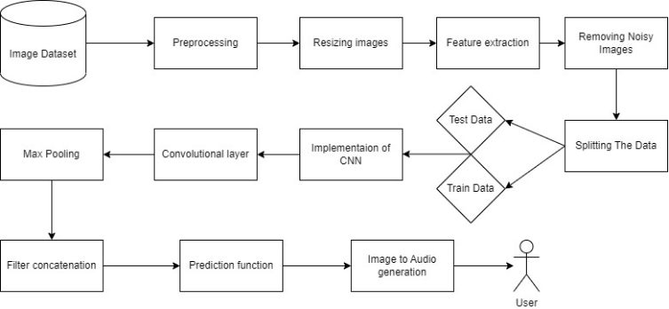

## Fig 4.1 – Architecture Diagram

* 1. **Data Flow Diagram:**

To illustrate the movement of information throughout a procedure or system, one might use a Data-Flow Diagram (DFD). A data-flow diagram does not include any decision rules or loops, as the flow of information is entirely one-way. A flowchart can be used to illustrate the steps used to accomplish a certain data-driven task. Several different notations exist for representing data-flow graphs.Structured data modeling (DFM) includes processes, flows, storage, and terminators.

## Data Flow Diagram Symbols:

**Process:**

A process is one that takes in data as input and returns results as output.



## Data Store:

In the context of a computer system, the term "data stores" is used to describe the various memory regions where data can be found. In other cases, "files" might stand in for data.



## Data Flow:

Data flows are the pathways that information takes to get from one place to another. Please describe the nature of the data being conveyed by each arrow.



## External Entity:

In this context, "external entity" refers to anything outside the system with which the system has some kind of interaction. These are the starting and finishing positions for inputs and outputs, respectively.



## Data Flow Diagram:

The whole system is shown as a single process in a level DFD. Each step in the system's assembly process, including all intermediate steps, are recorded here. The "basic system model" consists of this and 2-level data flow diagrams.

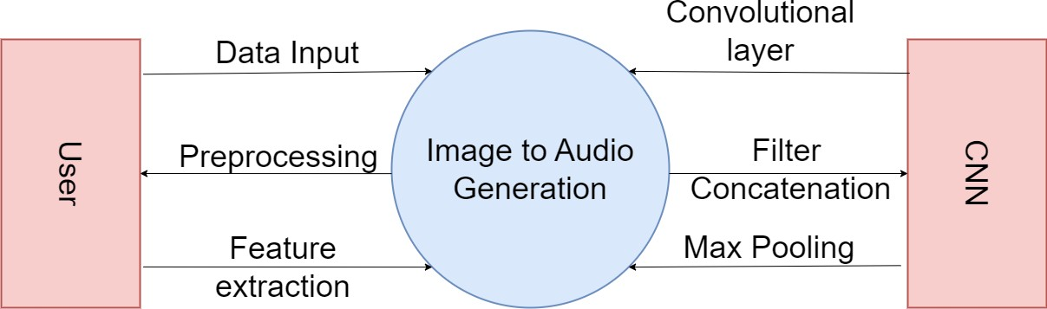

## Fig 4.2 – Data Flow Diagram Level 0

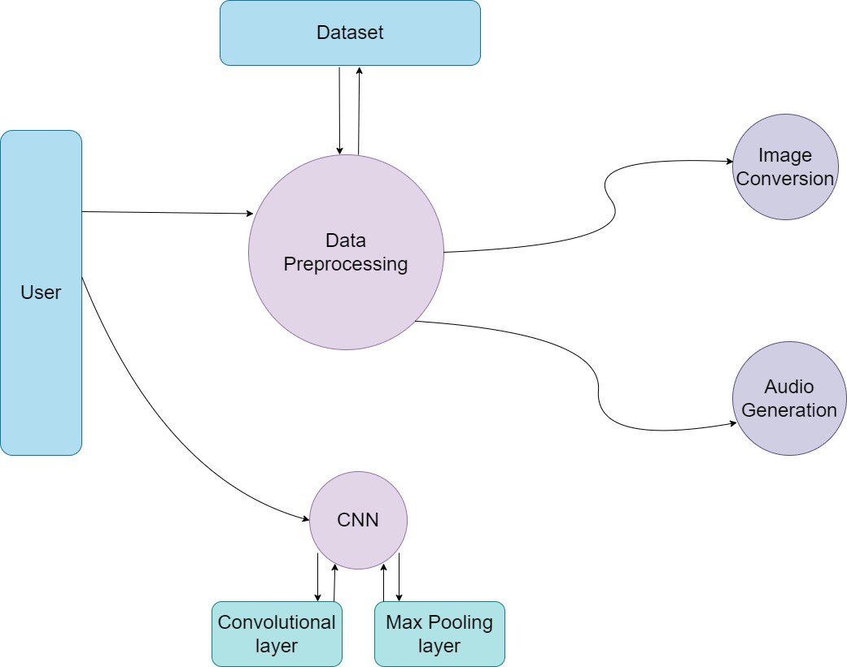

**Fig 4.2.1 – Data Flow Diagram Level 1**

## ER Diagram:

The relationships between database entities can be seen using an entity-relationship diagram (ERD). The entities and relationships depicted in an ERD can have further detail added to them via data object descriptions. In software engineering, conceptual and abstract data descriptions are represented via entity-relationship models (ERMs).

## Symbols Used:

External Entity



Attribute



Relationship



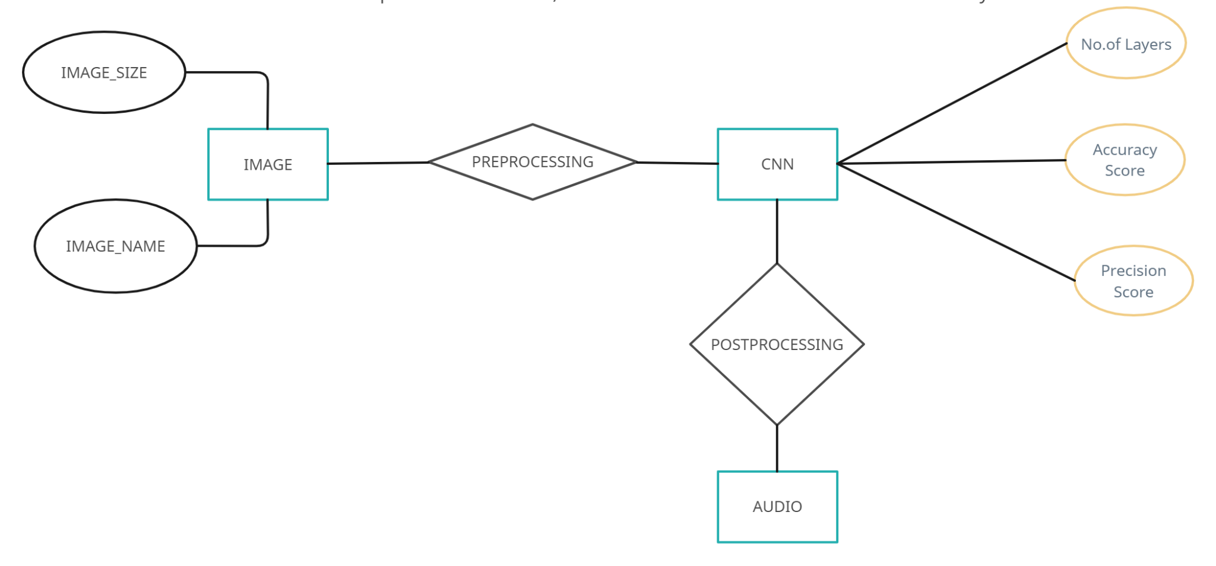

## Fig 4.3 – ER Diagram

* 1. **Use-Case Diagram:**

The possible interactions between the user, the dataset, and the algorithm are often depicted in a use case diagram. It's created at the start of the procedure.

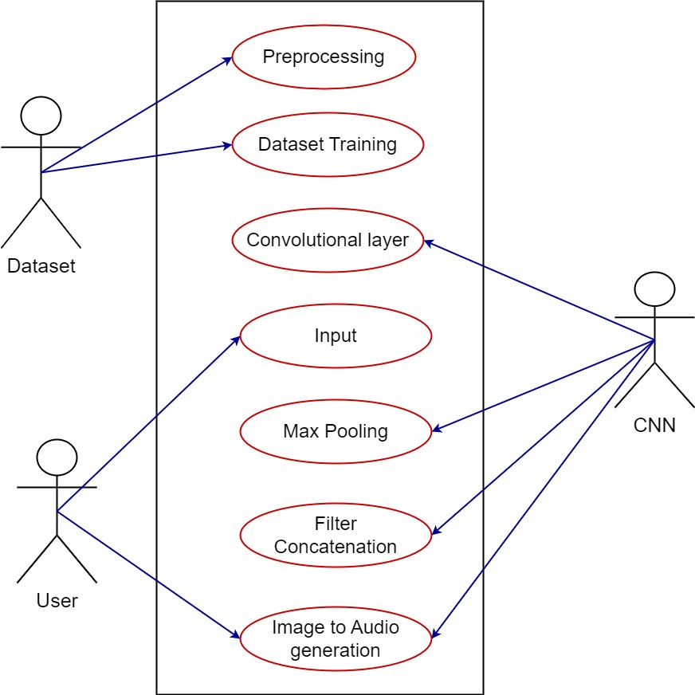

## Fig 4.4 – Use-Case Diagram

* 1. **Activity Diagram:**

An activity diagram, in its most basic form, is a visual representation of the sequence in which tasks are performed. It depicts the sequence of operations that make up the overall procedure. They are not quite flowcharts, but they serve a comparable purpose.

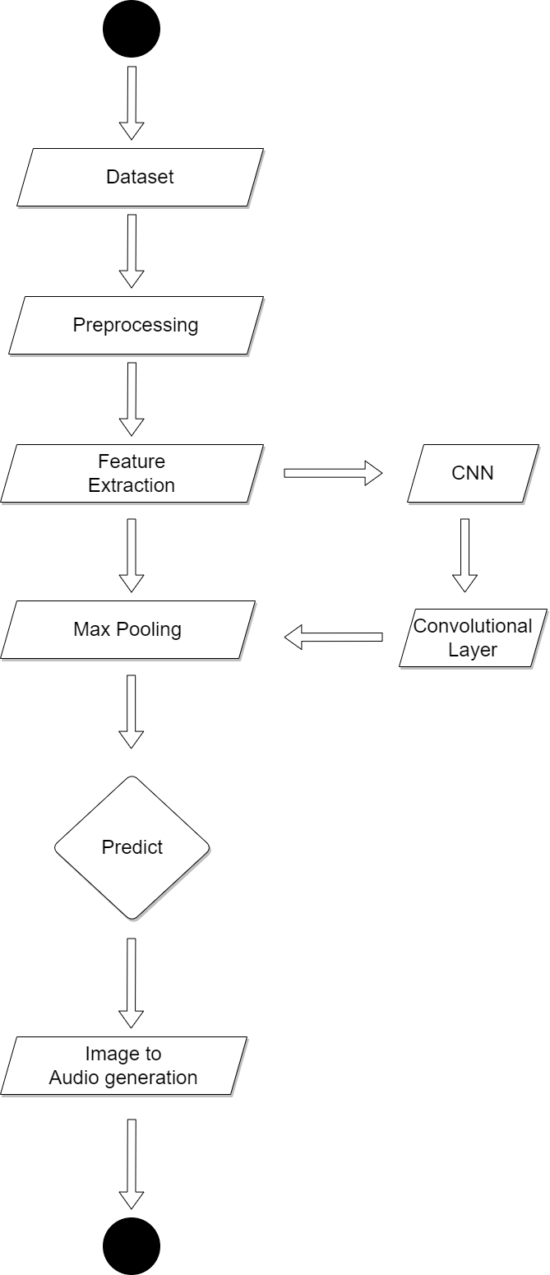

## Fig 4.5 – Activity Diagram

* 1. **Sequence Diagram:**

These are another type of interaction-based diagram used to display the workings of the system. They record the conditions under which objects and processes cooperate.

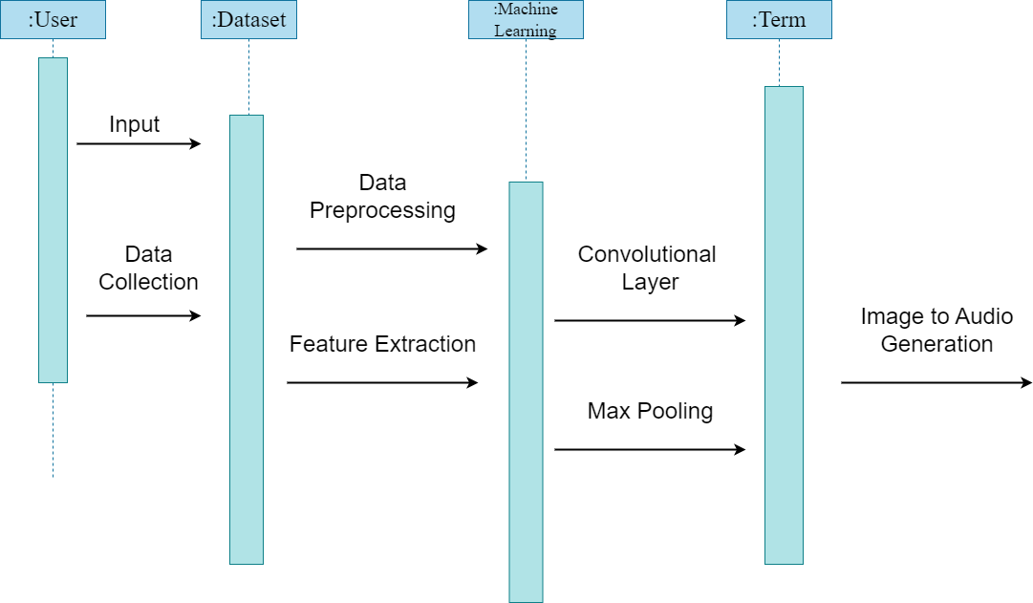

## Fig 4.6 – Sequence Diagram

* 1. **Class Diagram:**

In essence, this is a "context diagram," another name for a contextual diagram. It simply stands for the very highest point, the 0 Level, of the procedure. As a whole, the system is shown as a single process, and the connection to externalities is shown in an abstract manner.

* + - A + indicates a publicly accessible characteristic or action.
    - A - a privately accessible one.
    - A # a protected one.
    - A - denotes private attributes or operations.

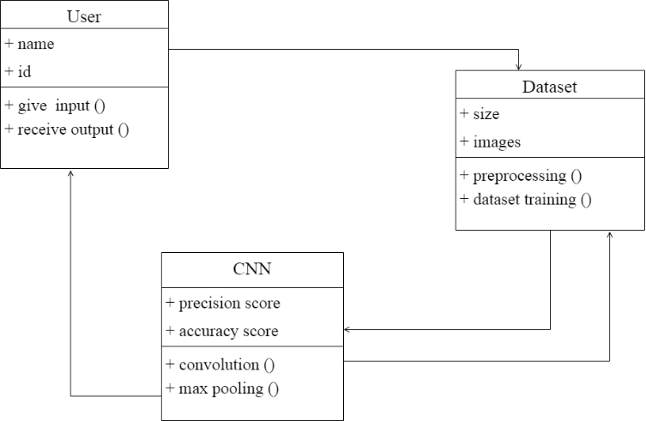

## Fig 4.7 – Class Diagram

**CHAPTER 5 MODULE DESCRIPTION**

## MODULE 1: IMAGE PRE-PROCESSING

The image pre-processing module is the first one in the CNN-LSTM image to audio conversion system. For the CNN-LSTM to be trained efficiently, this module is essential in getting the input picture data ready. A number of methods and algorithms are employed in the pre-processing module to improve the

quality of the input photos, extract valuable characteristics, and normalize the pixel values to a set scale.

The preprocessing module's first responsibility is to resize the photos to a particular resolution. In order to properly train the CNN-LSTM, this step makes sure that all of the images are the same size. Standardizing the picture size will assist the CNN-LSTM in recognising patterns and features from the images. Images of varied sizes may present difficulties in the network training.

The pre-processing module's function of contrast enhancement is also crucial. Contrast enhancement techniques are used to make visual characteristics more visible and assist the CNN-LSTM in locating important features that can be used to generate audio. Histogram equalization, adaptive histogram equalization, and gamma correction are a few well-liked methods for enhancing contrast. These methods work by enhancing the contrast and altering the intensity values of the pixels in the image.

The images may also be subjected to noise reduction techniques to get rid of any extraneous or distracting data that could harm CNN-LSTM training. Gaussian blur, the median filter, and the bilateral filter are common approaches. These filters function by minimizing the amount of noise in the image and smoothing it out.

Another crucial duty in the pre-processing module is feature extraction. In order to convert the image to audio, this method entails locating and extracting significant elements. Depending on the task at hand and the nature of the image data, several features may be extracted. Edge detection, texture analysis, and color analysis are a few methods of feature extraction that are frequently utilized. In order to generate reliable audio, the CNN-LSTM needs to be able to recognise key patterns and characteristics in the visual data.

Another essential stage in the pre-processing module is normalization. The process of normalization involves converting the image's pixel values to a uniform scale. To ensure that the CNN-LSTM can be trained successfully, this step is required. Standardization, which adjusts the pixel values to have a mean of zero and a standard deviation of one, or min-max scaling, which scales the pixel values to a range between 0 and 1, are two examples of normalization procedures.

In conclusion, the CNN-LSTM image to audio conversion system relies heavily on the image pre-processing module. The pre-processing programme improves the input photos' quality, extracts pertinent information, and scales the pixel values to a uniform scale. For the CNN-LSTM to learn and recognise significant patterns and characteristics in the image data that may be used for precise audio production, this module is crucial. The pre-processing module aids in the CNN-performance LSTM's optimization by giving the CNN-LSTM clean and pertinent data to train on.

## MODULE 2: CNN-LSTM ARCHITECTURE

The CNN-LSTM architecture module is the second component of the image to audio conversion system using CNN-LSTM. In order for the CNN-LSTM to learn the mapping between the input images and associated audio signals, the structure and parameters of the CNN-LSTM must be defined by this module.

Determining the number of LSTM layers, the number of pooling layers, the size of the filters, the number of convolutional layers, and the number of filters per layer are all tasks included in the CNN-LSTM architecture module. Applying a series of filters to the input image allows convolutional layers to learn features from the previously processed image data. The filters are made to recognise particular motifs or characteristics in the visual data, such as edges, forms, or textures. The

size of the filters and the number of filters per layer are hyperparameters that can be adjusted to enhance the CNN-performance. LSTM's

In order to minimize the dimensionality of the data and avoid overfitting, pooling layers are employed to downsample the output of the convolutional layers. The maximum value within a local region of the input data is chosen by the max pooling layer, which is the most popular kind of pooling layer.

The output of the convolutional layers is processed by LSTM layers, while the audio signal is produced by LSTM layers. The LSTM layer architecture can describe the temporal dependencies between the input image and audio signals and is built to handle sequential data. The CNN-performance LSTM's can be improved by adjusting the number of LSTM layers and the number of neurons in each layer, which are both hyperparameters.

Tasks like regularization, dropout, and activation functions might potentially be included in the CNN-LSTM architecture module. By including a penalty term in the loss function, regularization approaches stop overfitting. In order to avoid overfitting, the CNN-LSTM is trained with a technique called dropout that randomly removes some of the neurons. In order to describe complicated interactions between the input and output data, activation functions are employed to bring non-linearity into the CNN-LSTM.

Using a set of tagged images and the matching audio labels, the CNN-LSTM is trained after the CNN-LSTM architecture has been defined. By modifying its biases and weights using an optimization approach like gradient descent, the CNN-LSTM learns to map the input image data to the audio labels.

In conclusion, a crucial part of the CNN-LSTM image to audio conversion system is the CNN-LSTM architectural module. The CNN-structure LSTM's and parameters are described in this module, along with how the CNN-LSTM learns to produce audio signals from the pre-processed image data. The CNN-LSTM

architecture module enables the CNN-LSTM network to train effectively and understand the intricate mapping between the input visuals and related audio signals

## MODULE 3: POST PROCESSING

A series of feature vectors representing the likelihood of producing each audio sample is the CNN-output. LSTM's This series of feature vectors is examined by the post-processing module, which then creates the final audio signal. The post-processing module may carry out operations like denoising, spectrogram creation, and inverse Fourier transform in order to do this. Denoising aids in removing any noise that might be present in the feature vector sequence. In order to effectively manipulate and process the audio input, the sequence of feature vectors is represented in the frequency domain using spectrogram creation. The final audio signal is created by converting a series of feature vectors from the frequency domain to the time domain using the inverse Fourier transform.

The post-processing module may also perform tasks including spectrum smoothing, dynamic range compression, and waveform normalization. To make sure that the amplitude of the audio signal is within a particular range, waveform normalization is performed. By modifying the audio signal's dynamic range, dynamic range compression can improve its clarity and lower distortion. To lessen any abrupt transitions or abnormalities that might be present in the audio signal, spectral smoothing is applied.

In general, the post-processing module is a crucial component of the CNN-LSTM image to audio conversion system. It examines the CNN-output LSTM's and changes it into a useful illustration of the audio signal. Several methods to improve the final audio signal's quality, such as denoising, spectrogram creation, and

spectrum smoothing, may be included in the post-processing module. The post-processing module makes sure that the audio signal produced appropriately reflects the supplied visual data and is of excellent quality.

# CHAPTER 6

**SYSTEM IMPLEMENTATION AND RESULTS**

**Step1:** Click on browse files and choose an image in the local storage of the device.

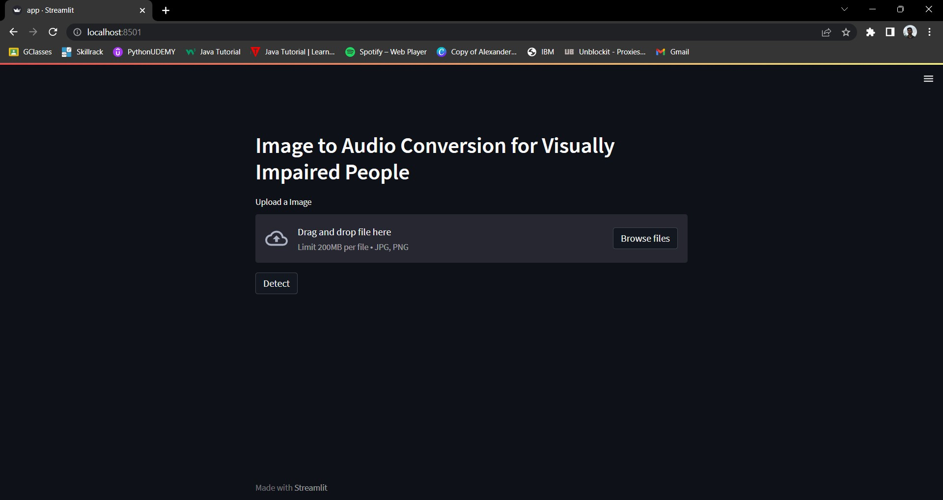

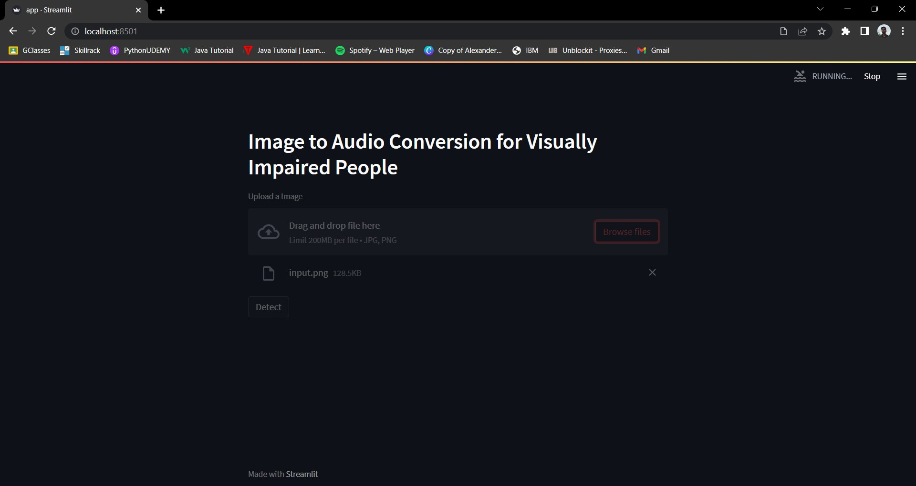**Step 2:** Once the image is uploaded click on the detect option to get the desired audio file.

**Step3:** The uploaded image pops up with the caption describing the image.

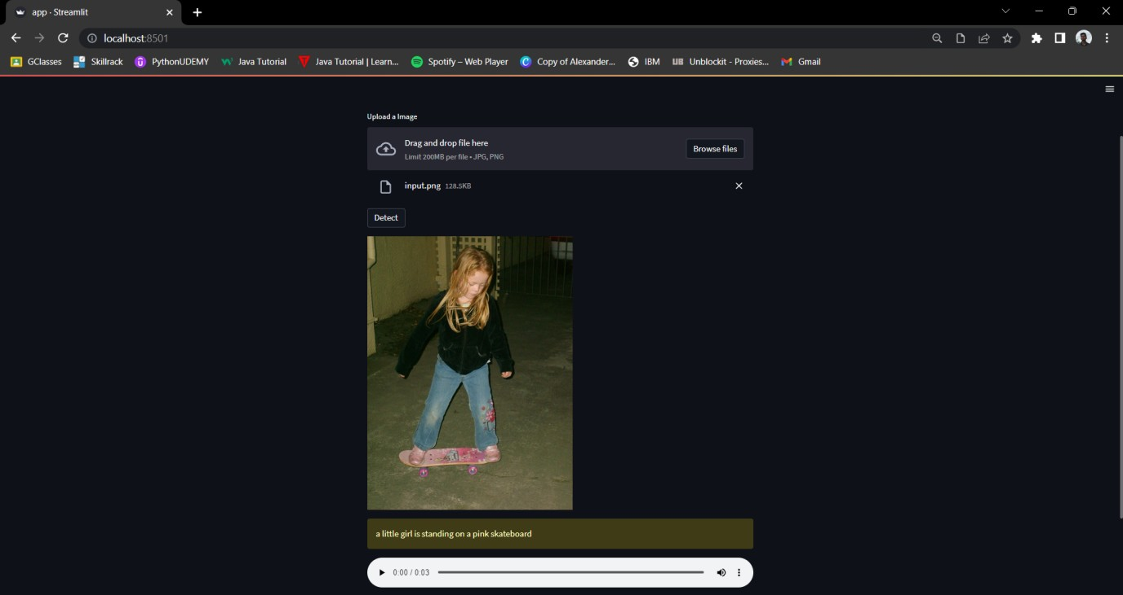

**Step4:** Click on the audio button to hear the audio which would describe the image.

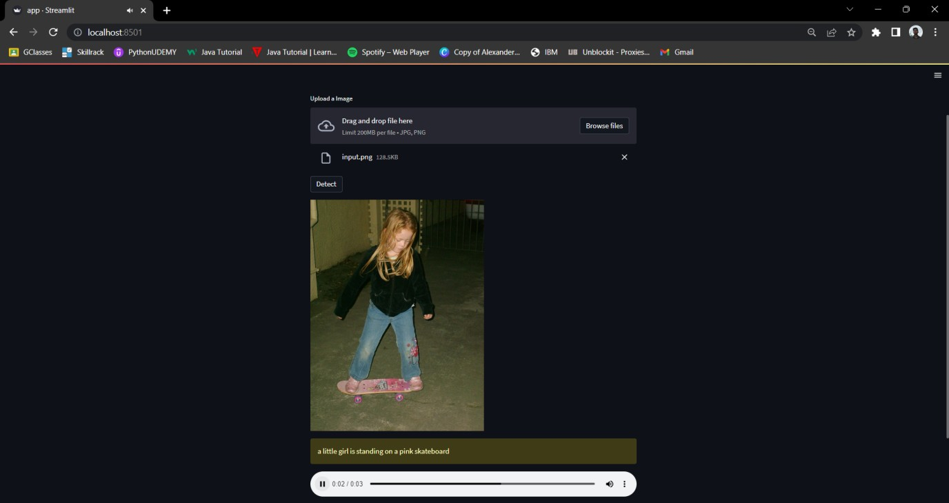

# CHAPTER 7 CONCLUSION AND FUTURE WORK

**CONCLUSION:**

In conclusion, this paper presents a deep learning-based approach for converting images to audio descriptions for visually impaired individuals. The proposed system utilizes convolutional neural networks (CNNs) to extract meaningful features from input images and generate corresponding audio descriptions in real-time. The system also incorporates attention mechanisms to focus on the most important features of the images, which enhances the accuracy and relevance of the generated audio descriptions.Overall, this paper contributes to the development of effective and reliable image to audio conversion systems using

CNNs, which have the potential to enhance the accessibility and inclusivity of our society by enabling visually impaired individuals to perceive and interact with visual content through audio descriptions. Future work could explore the extension of this approach to more complex image types, such as videos, and investigate the potential for commercial implementation of the system.

**FUTURE WORK:**

There are several potential areas for future enhancements of the proposed image to audio conversion system for visually impaired individualsImproving the accuracy and relevance of audio descriptions: While the system's performance was promising in our user study, there is always room for improvement in terms of accuracy and relevance of the generated audio descriptions. Future work could explore the use of advanced deep learning techniques, such as attention-based models or reinforcement learning, to improve the system's performance further.

★ Incorporating multi-modal feedback: The proposed system currently relies solely on audio feedback to convey image content to visually impaired individuals. Future work could explore the integration of additional modalities, such as haptic feedback or vibration, to provide a more immersive and informative experience for visually impaired users.

★ Extending the system to handle more complex image types: The proposed system is currently designed to handle simple images, such as those found in books or magazines. Future work could explore the extension of this approach to more complex image types, such as diagrams, maps, or even 3D images.

★ Expanding the dataset: The proposed system relies on a relatively small dataset of images to generate audio descriptions. Future work could explore the expansion of the dataset to include more diverse images, such as those from different cultures or domains, to improve the system's generalizability.

# APPENDIX 1 – SAMPLE CODE

## CODING

import streamlit as st

from keras.models import load_model import numpy as np

from keras.layers import Dense, LSTM, TimeDistributed, Embedding,

Activation, RepeatVector,Concatenate

from keras.models import Sequential, Model import cv2

from keras.preprocessing.sequence import pad_sequences from tqdm import tqdm

from tensorflow.keras.applications.resnet50 import ResNet50 import pyttsx3

from PIL import Image from gtts import gTTS import re

#engine = pyttsx3.init()

st.header('Image to Audio Conversion for Visually impaired People') vocab = np.load('vocab.npy', allow_pickle=True)

vocab = vocab.item()

inv_vocab = {v:k for k,v in vocab.items()}

print("+"*50)

print("vocabulary loaded")

embedding_size = 128

vocab_size = len(vocab) max_len = 40

image_model = Sequential()

image_model.add(Dense(embedding_size, input_shape=(2048,), activation='relu'))

image_model.add(RepeatVector(max_len))

language_model = Sequential()

language_model.add(Embedding(input_dim=vocab_size, output_dim=embedding_size, input_length=max_len))

language_model.add(LSTM(256, return_sequences=True))

language_model.add(TimeDistributed(Dense(embedding_size)))

conca = Concatenate()([image_model.output, language_model.output]) x = LSTM(128, return_sequences=True)(conca)

x = LSTM(512, return_sequences=False)(x) x = Dense(vocab_size)(x)

out = Activation('softmax')(x)

model = Model(inputs=[image_model.input, language_model.input], outputs

= out)

model.compile(loss='categorical_crossentropy', optimizer='RMSprop', metrics=['accuracy'])

model.load_weights('mine_model_weights.h5') print("="*150)

print("MODEL LOADED")

resnet =

ResNet50(include_top=False,weights='imagenet',input_shape=(224,224,3),p ooling='avg')

#resnet = load_model('model.h5') print("="*150)

print("RESNET MODEL LOADED")

def main():

uploaded_file = st.file_uploader('Upload a Image', type=['jpg', 'png'])

if uploaded_file is not None:

with open('./Images/input.png', 'wb') as f: f.write(uploaded_file.getvalue())

if st.button('Detect'):

image = cv2.imread('./Images/input.png')

image = cv2.cvtColor(image, cv2.COLOR_BGR2RGB) image = cv2.resize(image, (224,224))

image = np.reshape(image, (1,224,224,3))

incept = resnet.predict(image).reshape(1,2048) print("="*50)

print("Predict Features")

text_in = ['startofseq'] final = ''

print("="*50)

print("GETING Captions")

count = 0

while tqdm(count < 20): count += 1

encoded = []

for i in text_in:

encoded.append(vocab[i])

padded = pad_sequences([encoded], maxlen=max_len, padding='post', truncating='post').reshape(1,max_len)

sampled_index = np.argmax(model.predict([incept, padded])) sampled_word = inv_vocab[sampled_index]

if sampled_word != 'endofseq':

final = final + ' ' + sampled_word text_in.append(sampled_word)

final_string = re.sub(r'[^\w\s]','', final) img = Image.open('./Images/input.png')

st.image(img)

st.warning(final_string)

audio = gTTS(final_string, lang="en") audio.save('output.mp3')

audio_file = open('output.mp3', 'rb') audio_bytes = audio_file.read()

st.audio(audio_bytes, format='audio/mp3')

if name ==' main ': main()

# APPENDIX 2-SCREENSHOTS

**Sample output 1:**

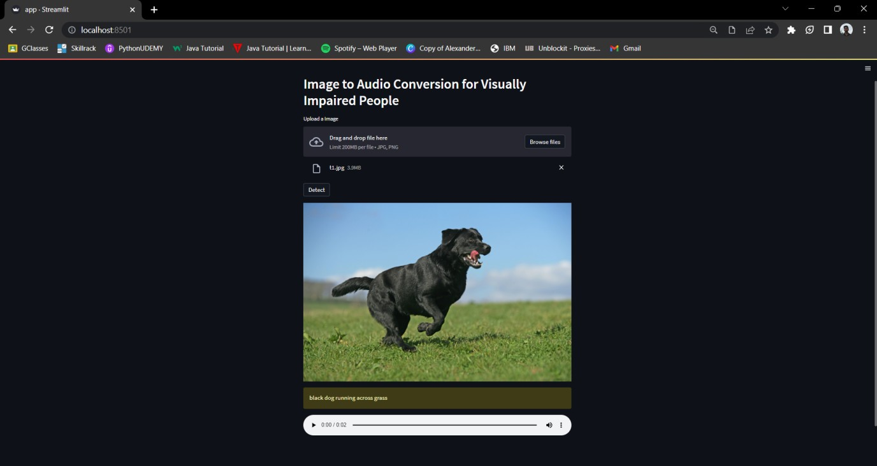

# Sample output 2:

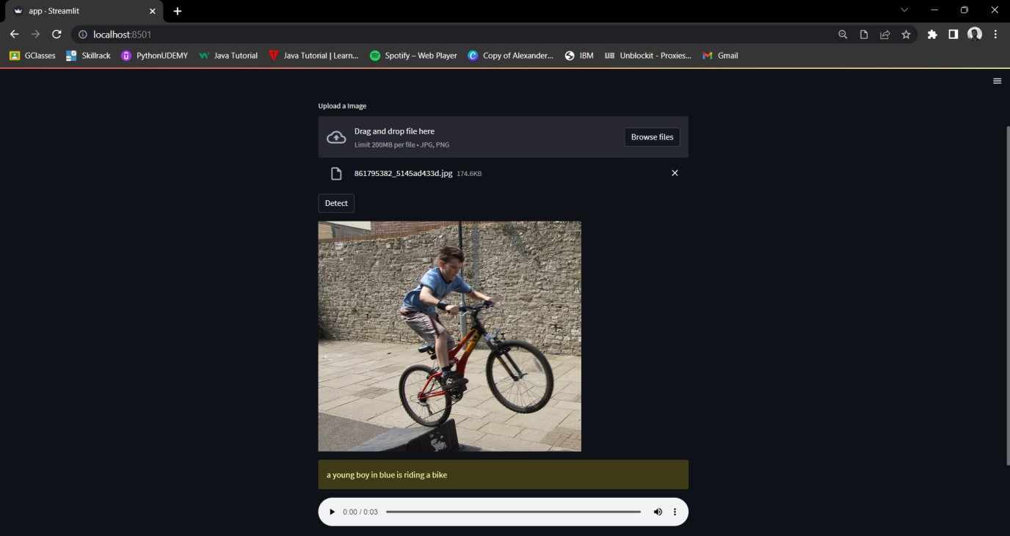

**REFERENCES**

1. Sneha.C. Madre, S.B. Gundre, “OCR Based Image Text to Speech Conversion Using MATLAB”, Second International Conference on Intelligent Computing and Control Systems (ICICCS), 2019
2. P Rohit, M S Vinay Prasad, S J Ranganatha Gowda, D R Krishna Raju, Imran Quadri, “Image Recognition Based Smart Aid For Visually Challenged People”, International Conference on Communication and Electronics Systems (ICCES), 2020
3. Sujata Deshmukh, Praditi Rede, Sheetal Sharma, Sahaana Iyer, “Voice-Enabled Vision For The Visually Disabled”, International Conference on Advances in Computing, Communication, and Control (ICAC3), 2022
4. Sai Aishwarya Edupuganti, Vijaya Durga Koganti, Cheekati Sri Lakshmi, Ravuri Naveen Kumar, Ramya Paruchuri, “Text and Speech Recognition for Visually Impaired People using Google Vision”, 2nd International Conference on Smart Electronics and Communication (ICOSEC), 2021
5. Abhishek Mathur, Akshada Pathare, Prerna Sharma, Sujata Oak, “AI based Reading System for Blind using OCR”, 3rd International conference on Electronics, Communication and Aerospace Technology (ICECA), 2019
6. Vaibhav V. Mainkar, Tejashree U. Bagayatkar, Siddhesh K. Shetye, Hrushikesh

R. Tamhankar, Rahul G. Jadhav, Rahul S. Tendolkar, “Raspberry pi based Intelligent Reader for Visually Impaired Persons”, 2nd International Conference on Innovative Mechanisms for Industry Applications (ICIMIA), 2020

1. Javavrinda Vrindavanam, Raghunandan Srinath, Anisa Fathima, S. Arpitha, Chaitanya S Rao, T. Kavya, “Machine Learning based approach to Image Description for the Visually Impaired”, Asian Conference on Innovation in Technology (ASIANCON), 2021
2. R. Prabha, M. Razmah, G. Saritha, RM Asha, Senthil G. A, R. Gayathiri, “Vivoice - Reading Assistant for the Blind using OCR and TTS”, International Conference on Computer Communication and Informatics (ICCCI), 2022
3. S. Durgadevi, K. Thirupurasundari, C. Komathi, S.Mithun Balaji, “Smart

Machine Learning System for Blind Assistance”, International Conference on Power, Energy, Control and Transmission Systems (ICPECTS), 2021

1. Sandeep Musale, Vikram Ghiye, “Smart reader for visually impaired”, 2nd International Conference on Inventive Systems and Control (ICISC), 2018